NEW

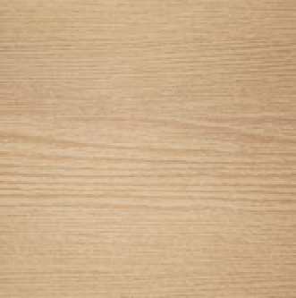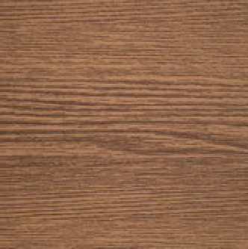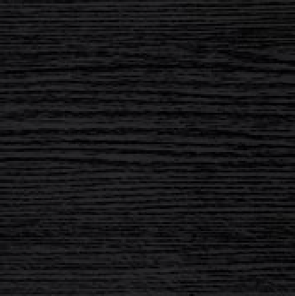

WOOD-EFFECT COLOURS

# BLONDE AUSTRALIAN EBONY

(All three colours displayed in Ash grain pattern)

**Introducing 3 new colour additions to our ezy HD2 wood effect colour range.**

ezy HD2 wood effect achieves maximum definition and maximum durability using an advanced powder on powder coating system applied to architectural aluminium.

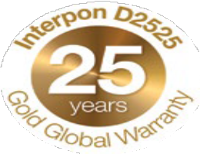

ezy HD2 was designed to meet the needs of surfaces that are particularly exposed to UV rays and extreme weather conditions.

# DFV Australia is the exclusive supplier of ezy HD2 wood effect coating in Australia.

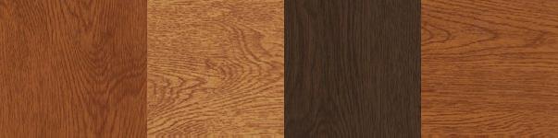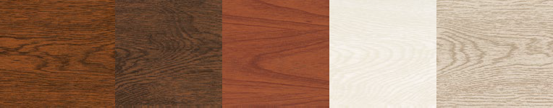

RED

AMERICAN

VOLCANO

GOLDEN

ROYAL

BROWN

WESTERN RED

WHITE

GREY

All 12 ezy HD2 wood effect colours are available in 3 grain patterns; Oak, Ash and Cedar.

**BEAUTY OF WOOD STRENGTH**

**OF ALUMINIUM**

ezy HD2 wood effect coating was created from technology developed and patented in Italy for the decoration and protection of architectural aluminium with a natural wood grain finish.

ezy HD2 is unique to the Australian market and produces a finish with a realistic look and feel as well as a superior, highly durable performance.



[**www.dfvaustralia.com.au**](http://www.dfvaustralia.com.au/)

Cnr of Lytton and Lackey Roads Moss Vale

PO Box 147 Moss Vale NSW 2577 PH: 02 4869 1069

Email: [sales@dfvaust.com.au](mailto:sales@dfvaust.com.au)